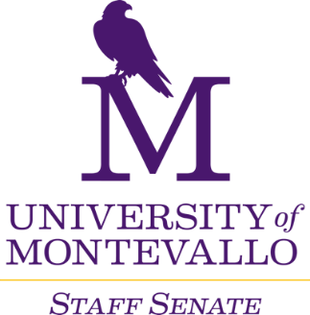

**Thursday, March 6, 2025**

**Merrill Room**

**10 a.m.-12 p.m.**

**AGENDA**

1. Welcome
2. Approval of minutes
3. Dr. Bentley – SB129
4. Old Business
   1. Staff Performance Evaluation revisions (approved!)
   2. Staff Survey
5. Reports from Liaisons
6. Reports from Committees
   1. Campus Communication
   2. Events, Services, and Recognition
   3. Finance and Staff Salary Review
   4. Policies and Procedures
   5. Professional Development
7. Reports from Departments
8. Dr. Stewart – University Update
9. Next Meeting
   1. April 3, 2025
   2. May 1, 2025(?)
   3. June 5, 2025(?)